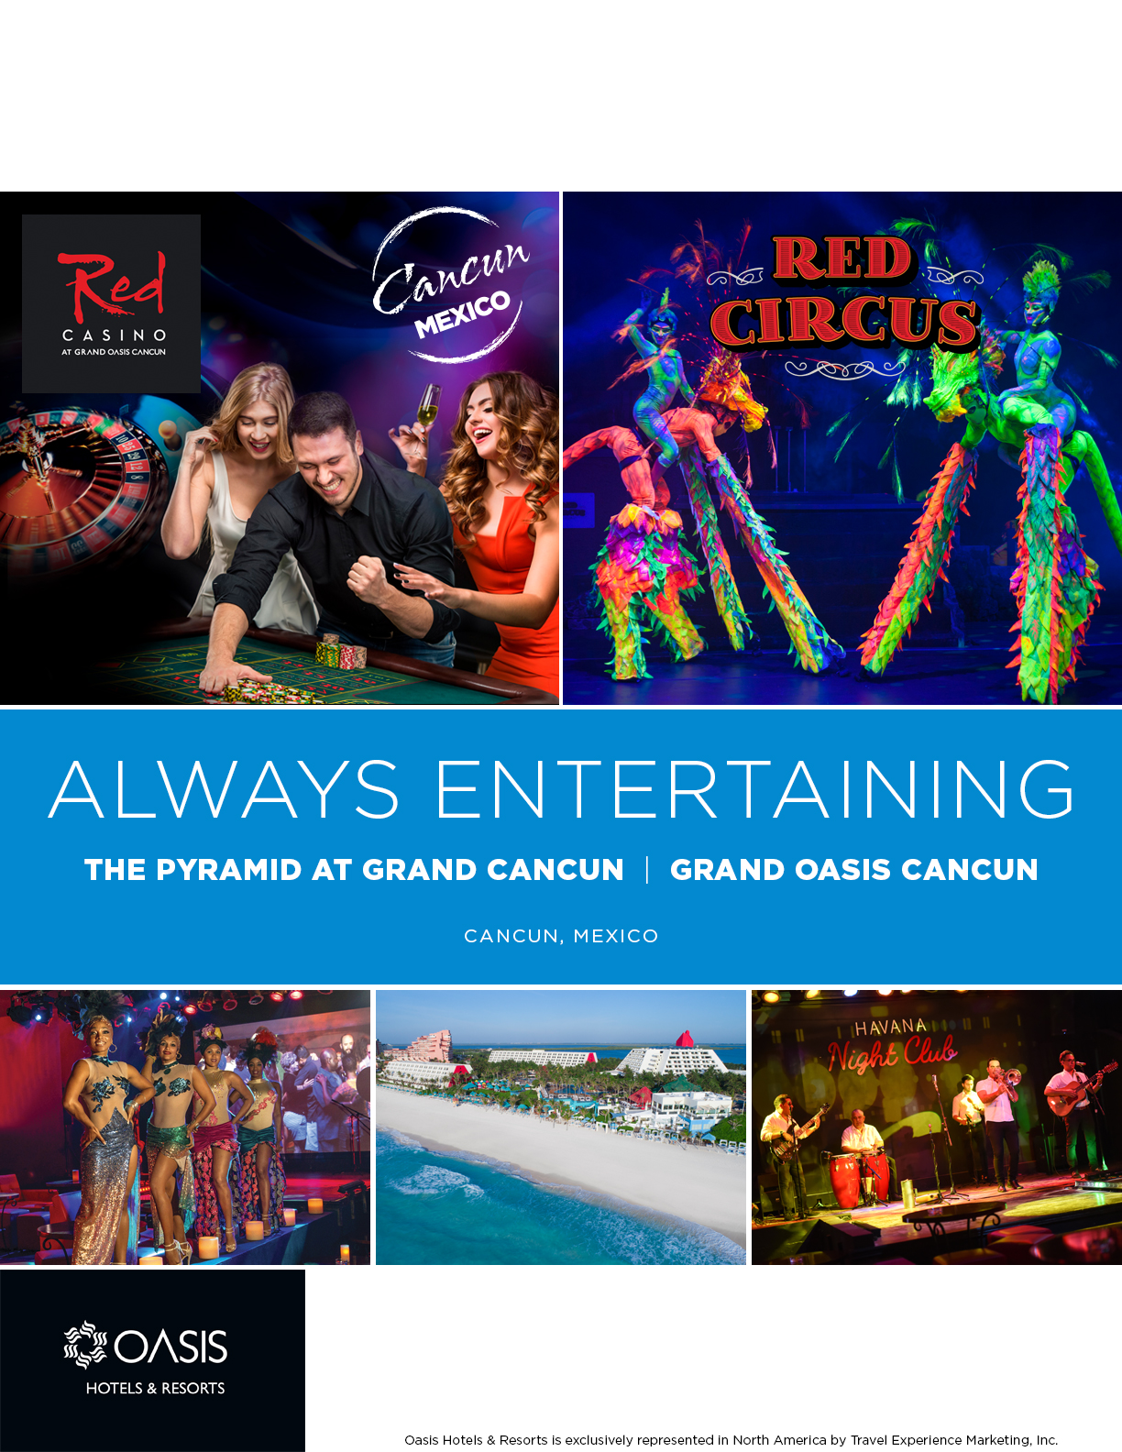

Agency Logo

[Agent Name]

[Agency Name]

[Agency Phone Number]

[Agency Email Address]

**$000**

0 days / 0 nights land only, per person

All-Inclusive Resort includes room, meals & drinks